‘There isn’t really anything magical about it’: Why more millennials are avoiding sex
By Tara Bahrampour
August 2, 2016
https://www.washingtonpost.com/local/social-issues/there-isnt-really-anything-magical-about-it-why-more-millennials-are-putting-off-sex/2016/08/02/e7b73d6e-37f4-11e6-8f7c-d4c723a2becb_story.html?noredirect=on&utm_term=.90b3e4eb9301

Sam Wei, a 26-year-old financial analyst in Chicago, has not had sex since her last relationship ended 18 months ago. She makes out with guys sometimes, and she likes to cuddle.
“To me, there’s more intimacy with having someone there next to you that you can rely on without having to have sex,” she said. “I don’t want to do anything that would harm the relationship and be something that we can’t come back from.”
Sam Wei, 26, finds “intellectual conversation more stimulating and more pleasurable than having sex sometimes.” (Courtesy of Sam Wei)
It’s a less sexy time to be young than it used to be, despite millennials’ reputation as bed-hoppers frolicking like the characters on “Girls.” A study published Tuesday in the journal Archives of Sexual Behavior finds that younger millennials — born in the 1990s — are more than twice as likely to be sexually inactive in their early 20s as the previous generation was. Even older millennials are more sexually active than this younger group is.
Recent research also shows that, overall, millennials — people born between the early 1980s and 2000 — have fewer sexual partners than baby boomers and those in Generation X, the group immediately preceding them.
Granted, the vast majority of young adults are still having sex, but an increasing number of them appear to be standing on the sidelines.
Delaying sex is not necessarily bad, experts say: Being intentional about when to have sex can lead to stronger relationships in the long run. The trend may also reflect that women feel more empowered to say no, said Stephanie Coontz, director of research at the Council on Contemporary Families.
“As people have gotten much more accepting of all sorts of forms of consensual sex, they’ve also gotten more picky about what constitutes consent,” Coontz said. “We are far less accepting of pressured sex.”
But some experts are concerned that the drop-off reflects the difficulty some young people are having in forming deep romantic connections. They cite other reasons for putting off sex, including pressure to succeed, social lives increasingly conducted on-screen, unrealistic expectations of physical perfection encouraged by dating apps and wariness over date rape.

‘Anti-sexual’ communication
Noah Patterson, 18, likes to sit in front of several screens simultaneously: a work project, a YouTube clip, a video game. To shut it all down for a date or even a one-night stand seems like a waste. “For an average date, you’re going to spend at least two hours, and in that two hours I won’t be doing something I enjoy,” he said.
It’s not that he doesn’t like women. “I enjoy their companionship, but it’s not a significant part of life,” said Patterson, a Web designer in Bellingham, Wash.
He has never had sex, although he likes porn. “I’d rather be watching YouTube videos and making money.” Sex, he said, is “not going to be something people ask you for on your résumé.”
That attitude does not surprise Helen Fisher, a biological anthropologist at Rutgers University and chief scientific adviser to the dating site Match.com.
“It’s a highly motivated, ambitious generation,” she said. “A lot of them are afraid that they’ll get into something they can’t get out of and they won’t be able to get back to their desk and keep studying.”
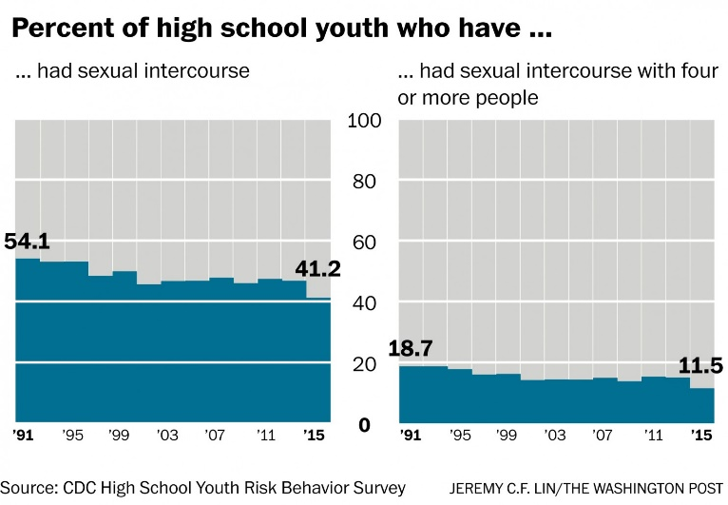

According to the new report, 15 percent of 20- to 24-year-olds have not had sex since turning 18, up from 6 percent in the early 1990s. And a study published in the same journal last year found that although millennials are more accepting of extramarital sex than earlier generations, they reported fewer sexual partners than any group since the 1960s — an average of eight, compared with 11 for boomers and 10 for Generation X.
The decline seems likely to continue: According to the latest data from the Centers for Disease Control and Prevention, the portion of high school students who have had sex fell last year to 41 percent from 54 percent in 1991 and about 47 percent in 2013. The portion who reported sleeping with multiple partners also declined, from about 19 percent in 1991 to about 12 percent last year.
Among millennials, the effects are most dramatic among those born in the mid-1990s and later — the first cohort to come of age when smartphones were ubiquitous.

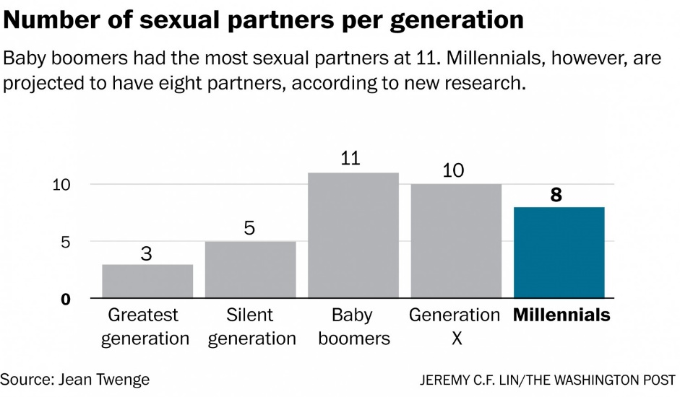

“This was the group that really started to communicate by screens more and by talking to their friends in person less,” said researcher Jean Twenge, lead author of the two studies.
So has sex declined because people are not meeting in person? Perhaps in part. But online life can also affect offline life in more subtle ways, especially when potential mates can disappear forever with the swipe of a thumb.
“It ends up putting a lot of importance on physical appearance, and that, I think, is leaving out a large section of the population,” said Twenge, who teaches psychology at San Diego State University. “For a lot of folks who are of average appearance, marriage and stable relationships was where they were having sex.” Unlike in face-to-face meetings where “you can seduce someone with your charm,” she said, dating apps are “leaving some people with fewer choices and they might be more reluctant to search for partners at all.”
It does not help that many millennials are relatively unfamiliar with the kind of down time it takes to really get to know a partner.
“The nature of communication now is anti-sexual,” said Norman Spack, associate clinical professor of pediatrics at Harvard Medical School. “People are not spending enough time alone just together. There’s another gorilla in the room: It’s whatever is turned on electronically.”
Alexandra Wolff, 19, had hoped to find romance in college. In high school, she and her friends were so focused on schoolwork that they did not date. But as a freshman last year at George Washington University, she found that between meeting new friends, attending classes and participating in extracurricular activities, she still did not have time.
“I don’t involve myself in the scene of frat parties and hookup culture . . . but it seems like every other option is so time-consuming and very hard to seek out,” said Wolff, who has never had sex. “It’s not like I’m saving myself for anything; it’s more like, I’ve been busy.”
At Tulane University, in New Orleans, Wolff’s high school classmate Claudia W., 19, feels like an odd duck in a sea of Tinder users. She wants what she calls an “old-fashioned” relationship, leading to marriage and kids. But fellow students are into “very casual one-night stands, going to bars and going home with someone,” she said.
Claudia, who did not want her last name used because “I don’t want all my professors reading about how I’m a virgin,” said her parents worry.
“They always ask me: ‘Are you against relationships? Why don’t you have a boyfriend?’ My mom — she hooked up all the time in college — she’s like, ‘I would still love you, but are you gay?’ But for me, it’s not anything about chastity or fear of sex. . . . I’m just like, ‘Eh, it’ll happen.’ ”

Wary of ‘catching feelings’
Millennials have been called the most cautious generation — the first to grow up with car seats and bike helmets, the first not allowed to walk to school or go to the playground alone.
The sense of caution sometimes manifests itself as a heightened awareness of emotional pitfalls. For example, some young people speak disparagingly of the messy emotional state love and lust can engender, referring to it as “catching feelings.”
This generation has also grown up in an age when it is possible to inflict suffering in ways that are both hidden and horrifyingly public, such as cyberbullying or posting compromising pictures online. In such an environment, young people have developed what some see as necessary defenses and others view as thin skin.
“On college campuses, you see older people scratching their heads about ‘safe spaces.’ ” Twenge said. “That’s about emotional safety, this new idea of words being more harmful,” referring to “trigger warnings” and other terms college-age people use to talk about potentially trauma-inducing stimuli.
Meanwhile, in efforts to counteract hookup and drinking culture, some campuses have begun instigating “yes means yes” rules stipulating that each step of a sexual encounter requires verbal consent. For some, staying away altogether can feel less treacherous.
For his part, Leo Fusco, a 25-year-old construction worker and subcontractor in Oakland, Calif., has refrained from sex in part because he is repelled by the hookup culture.
“I’ve overheard conversations where every detail was given — ‘We were in this position for this long, and then we were in that position’ — and that’s a major turnoff for me,” he said. “There’s a lot of people my age who have no filter in terms of how they express themselves in public.”
Isn’t he curious about what sex is like? “I’m curious on a physical level, like I’m curious about how a new sandwich would taste, but it’s not like a driving curiosity.” Besides, he said, “I don’t particularly like not being in control of myself.”
To Spack, the Harvard professor, that is sad. “Everyone’s missing out on a good time,” he said.
But Fisher, the Rutgers anthropologist, is not worried. “It’s probably a good thing,” she said. Noting that baby boomers were known not only for free love but also for high divorce rates, she added, “I think [taking it slowly] is going to lead to better first marriages.”
In the end, she predicted, biology will prevail. “Sex is a powerful drive, and so is romantic love. . . . The sex system is way below the cortex. It’s way below the limbic system,” on a level with thirst and hunger.
“They’ll get to the sex,” she said. “I’m positive of that.”

Tara Bahrampour, a staff writer based in Washington, D.C., writes about aging and generations.

